**Pandas Assignment:**

Q1. How do you load a CSV file into a Pandas DataFrame?

Ans: We can load CSV file into DataFrame using pd.read_csv

import pandas as pd

df = pd.read_csv('imdb_rating.csv')

df

Q2. How do you check the data type of a column in a Pandas DataFrame?

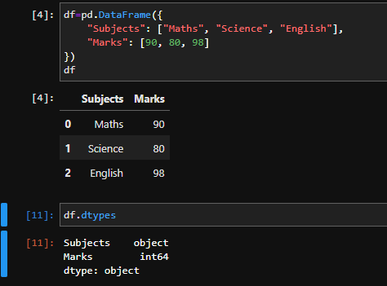

Q3. How do you select rows from a Pandas DataFrame based on a condition?

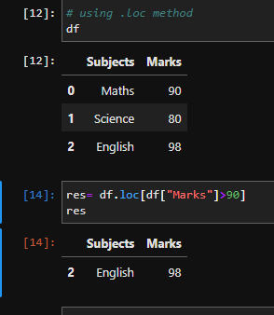

Q4. How do you rename columns in a Pandas DataFrame?

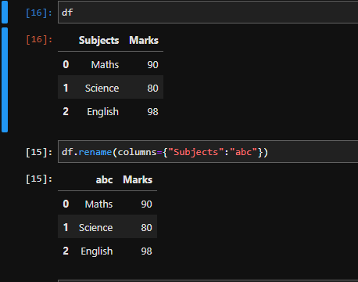

5. How do you drop columns in a Pandas DataFrame?

Using drop method.

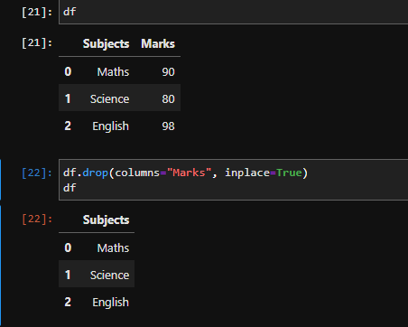

6. How do you find the unique values in a column of a Pandas DataFrame?

Using unique() method.

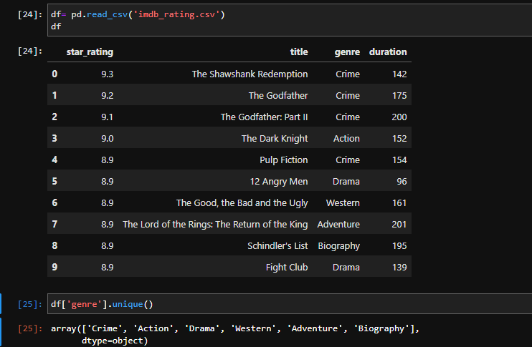

7. How do you find the number of missing values in each column of a Pandas DataFrame?

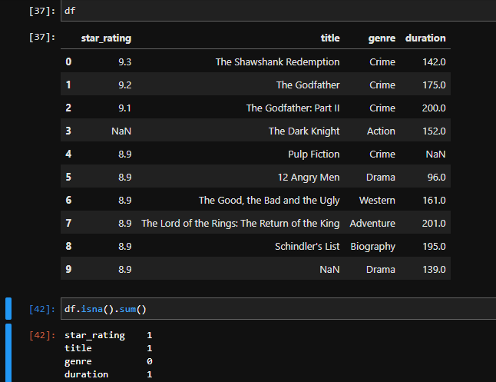

Q8. How do you fill missing values in a Pandas DataFrame with a specific value?

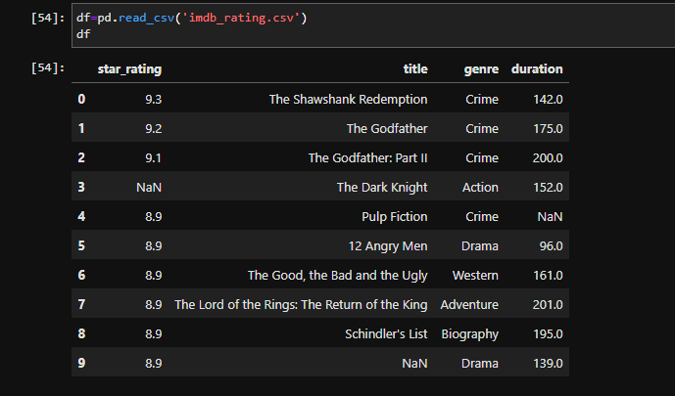

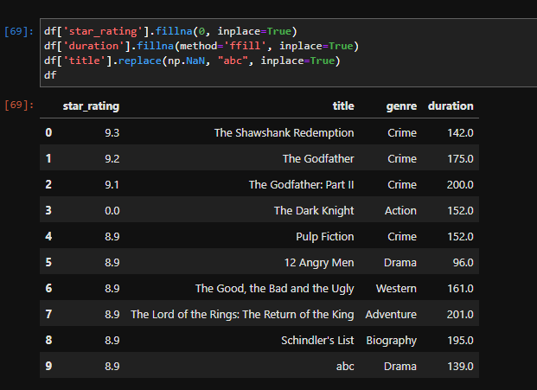

9. How do you concatenate two Pandas DataFrames?

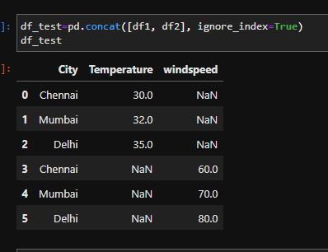

Q10. How do you merge two Pandas DataFrames on a specific column?

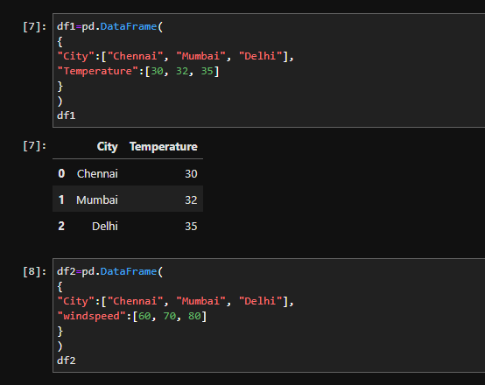

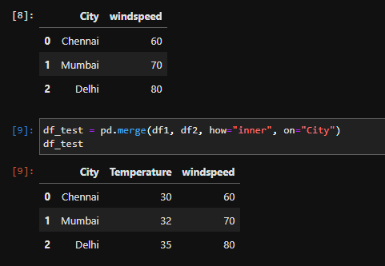

Q11. How do you group data in a Pandas DataFrame by a specific column and apply an aggregation function?

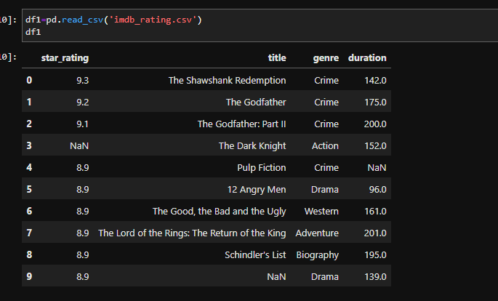

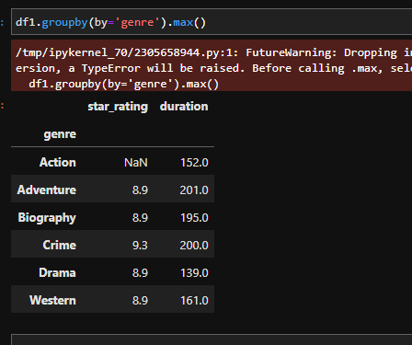

Q12. How do you pivot a Pandas DataFrame?

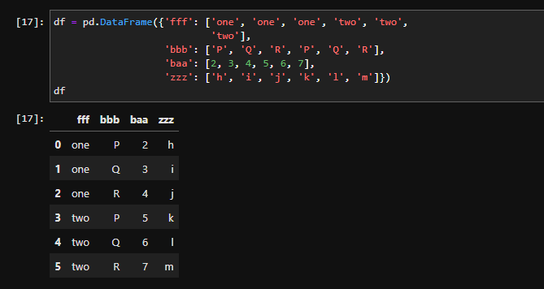

Q13. How do you change the data type of a column in a Pandas DataFrame?

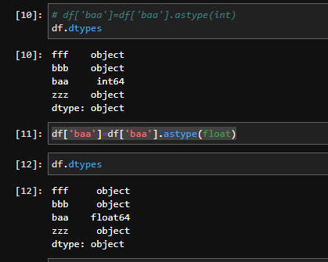

Q14. How do you sort a Pandas DataFrame by a specific column?

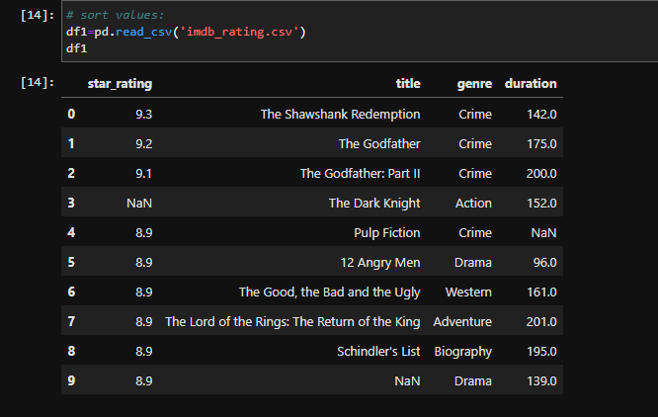

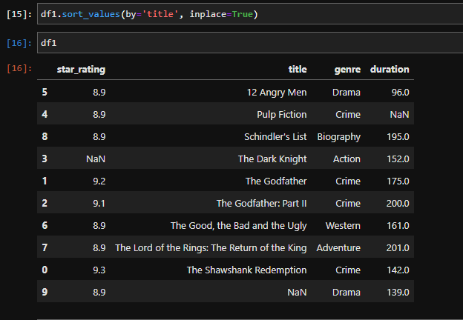

Q15. How do you create a copy of a Pandas DataFrame?

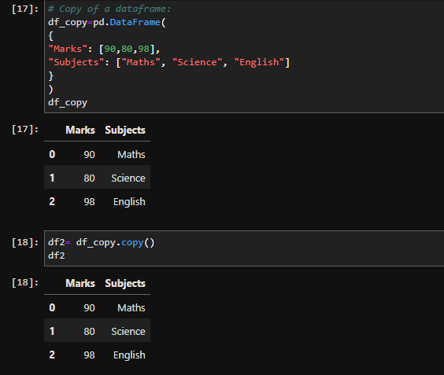

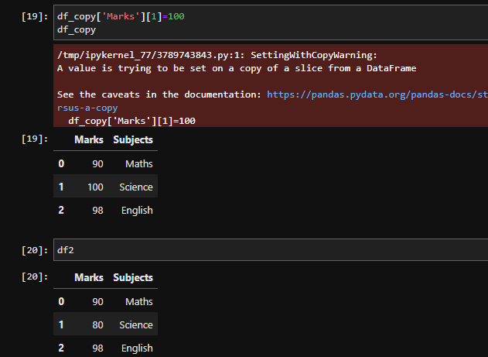

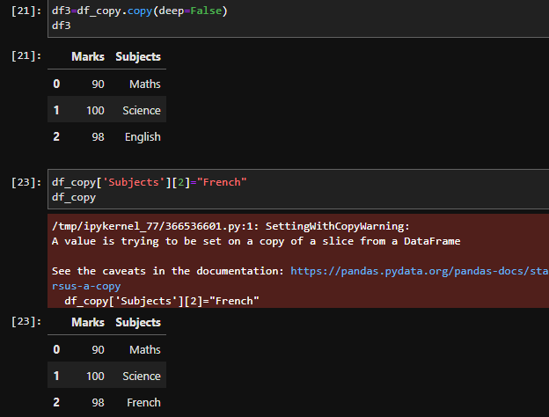

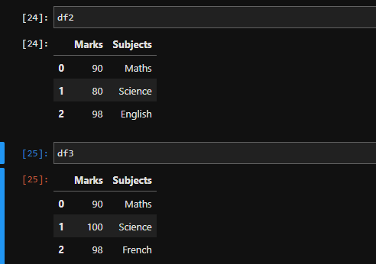

Q16. How do you filter rows of a Pandas DataFrame by multiple conditions?

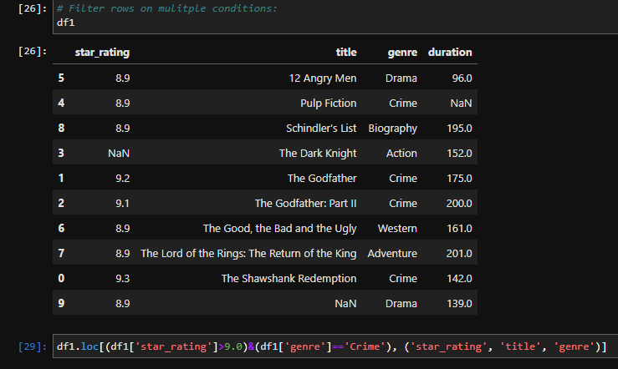

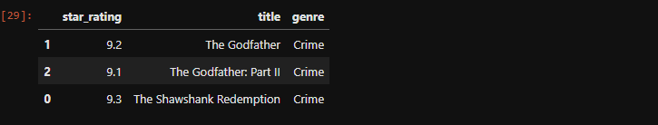

Q17. How do you calculate the mean of a column in a Pandas DataFrame?

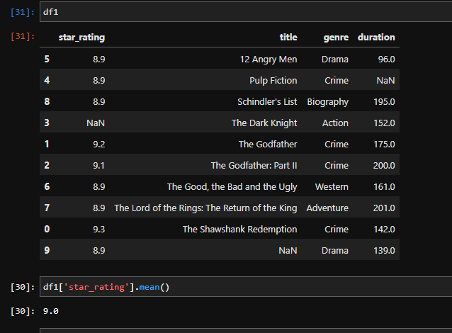

Q18. How do you calculate the standard deviation of a column in a Pandas DataFrame?

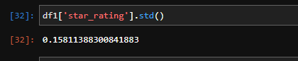

Q19. How do you calculate the correlation between two columns in a Pandas DataFrame?

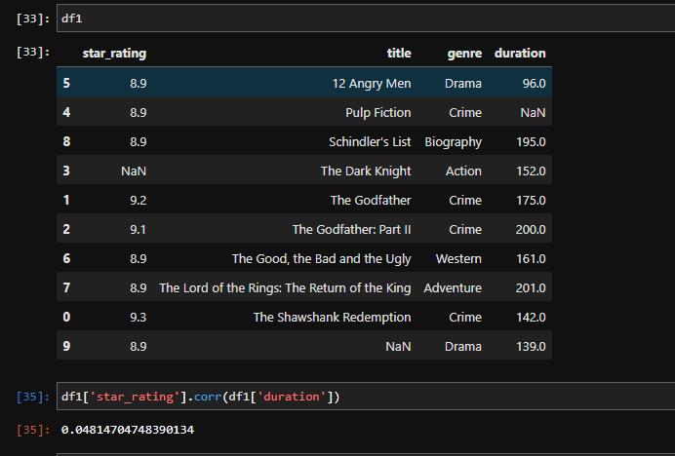

Q20. How do you select specific columns in a DataFrame using their labels?

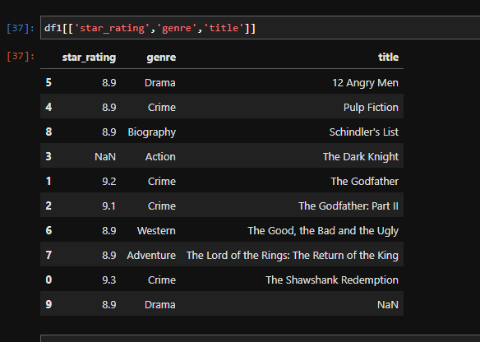

Q21. How do you select specific rows in a DataFrame using their indexes?

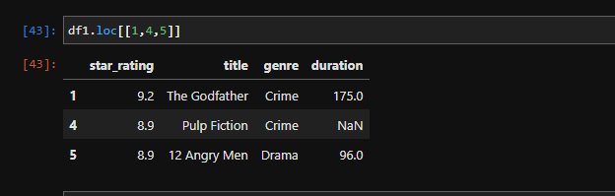

Q22. How do you sort a DataFrame by a specific column?

Repetitve question – Q14.

Q23. How do you create a new column in a DataFrame based on the values of another column?

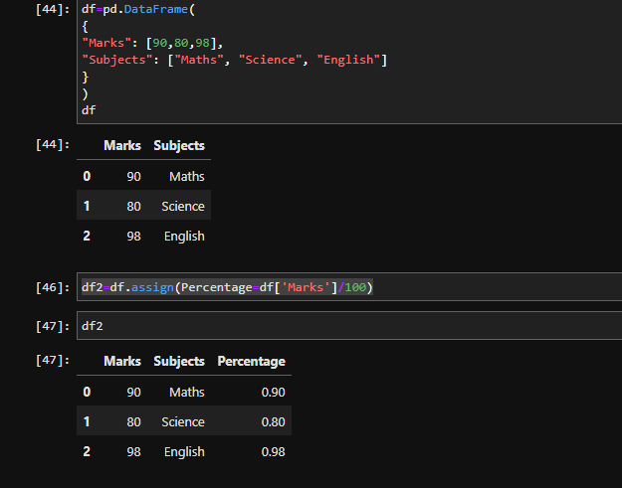

Q24. How do you remove duplicates from a DataFrame?

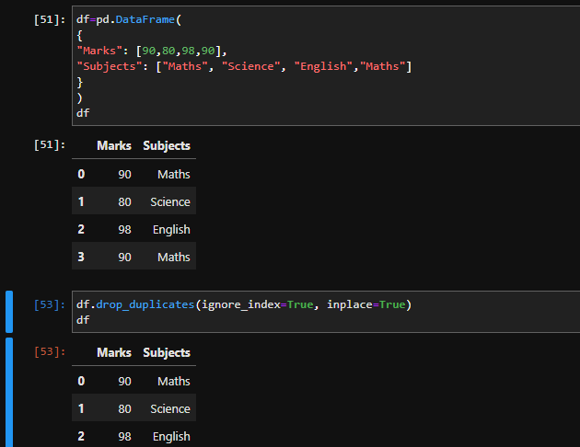

Q25. What is the difference between .loc and .iloc in Pandas?

.loc – To retrieve the specific rows and columns using labels (explicit indexing).

.iloc – To retrieve the specific rows and columns using indexes (implicit indexing).